**2048 RGB Led Matrix**

This is an embedded systems project of a recreation of the 2048 game onto an RGB led matrix.

The main components include: 3 x TLC5940 (daisy-chained pwm driver), 16 x RGB leds, atmega1284 microcontroller, button inputs.

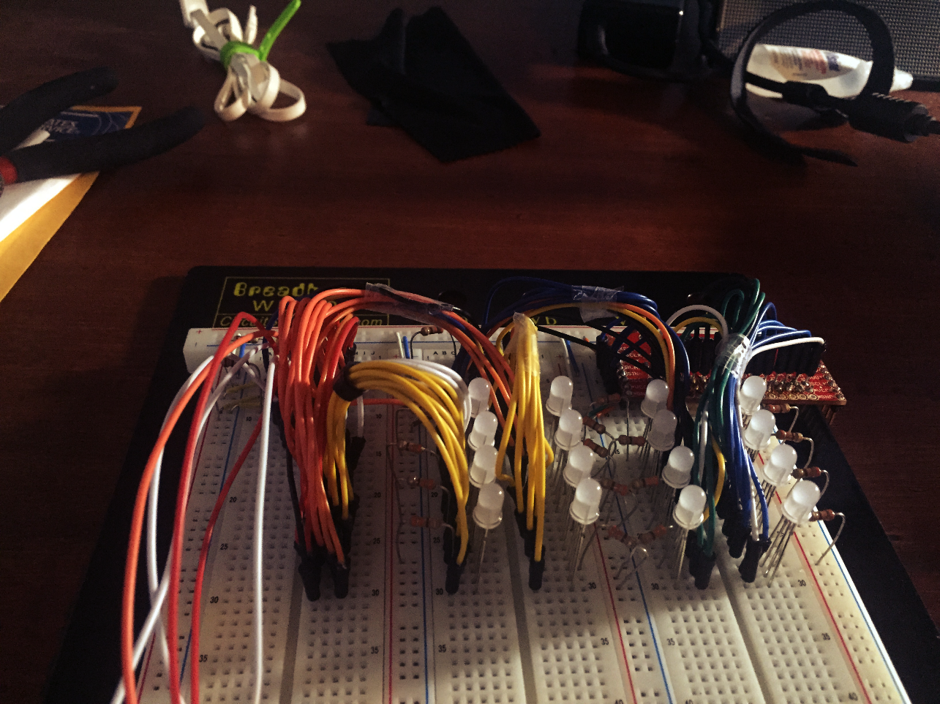

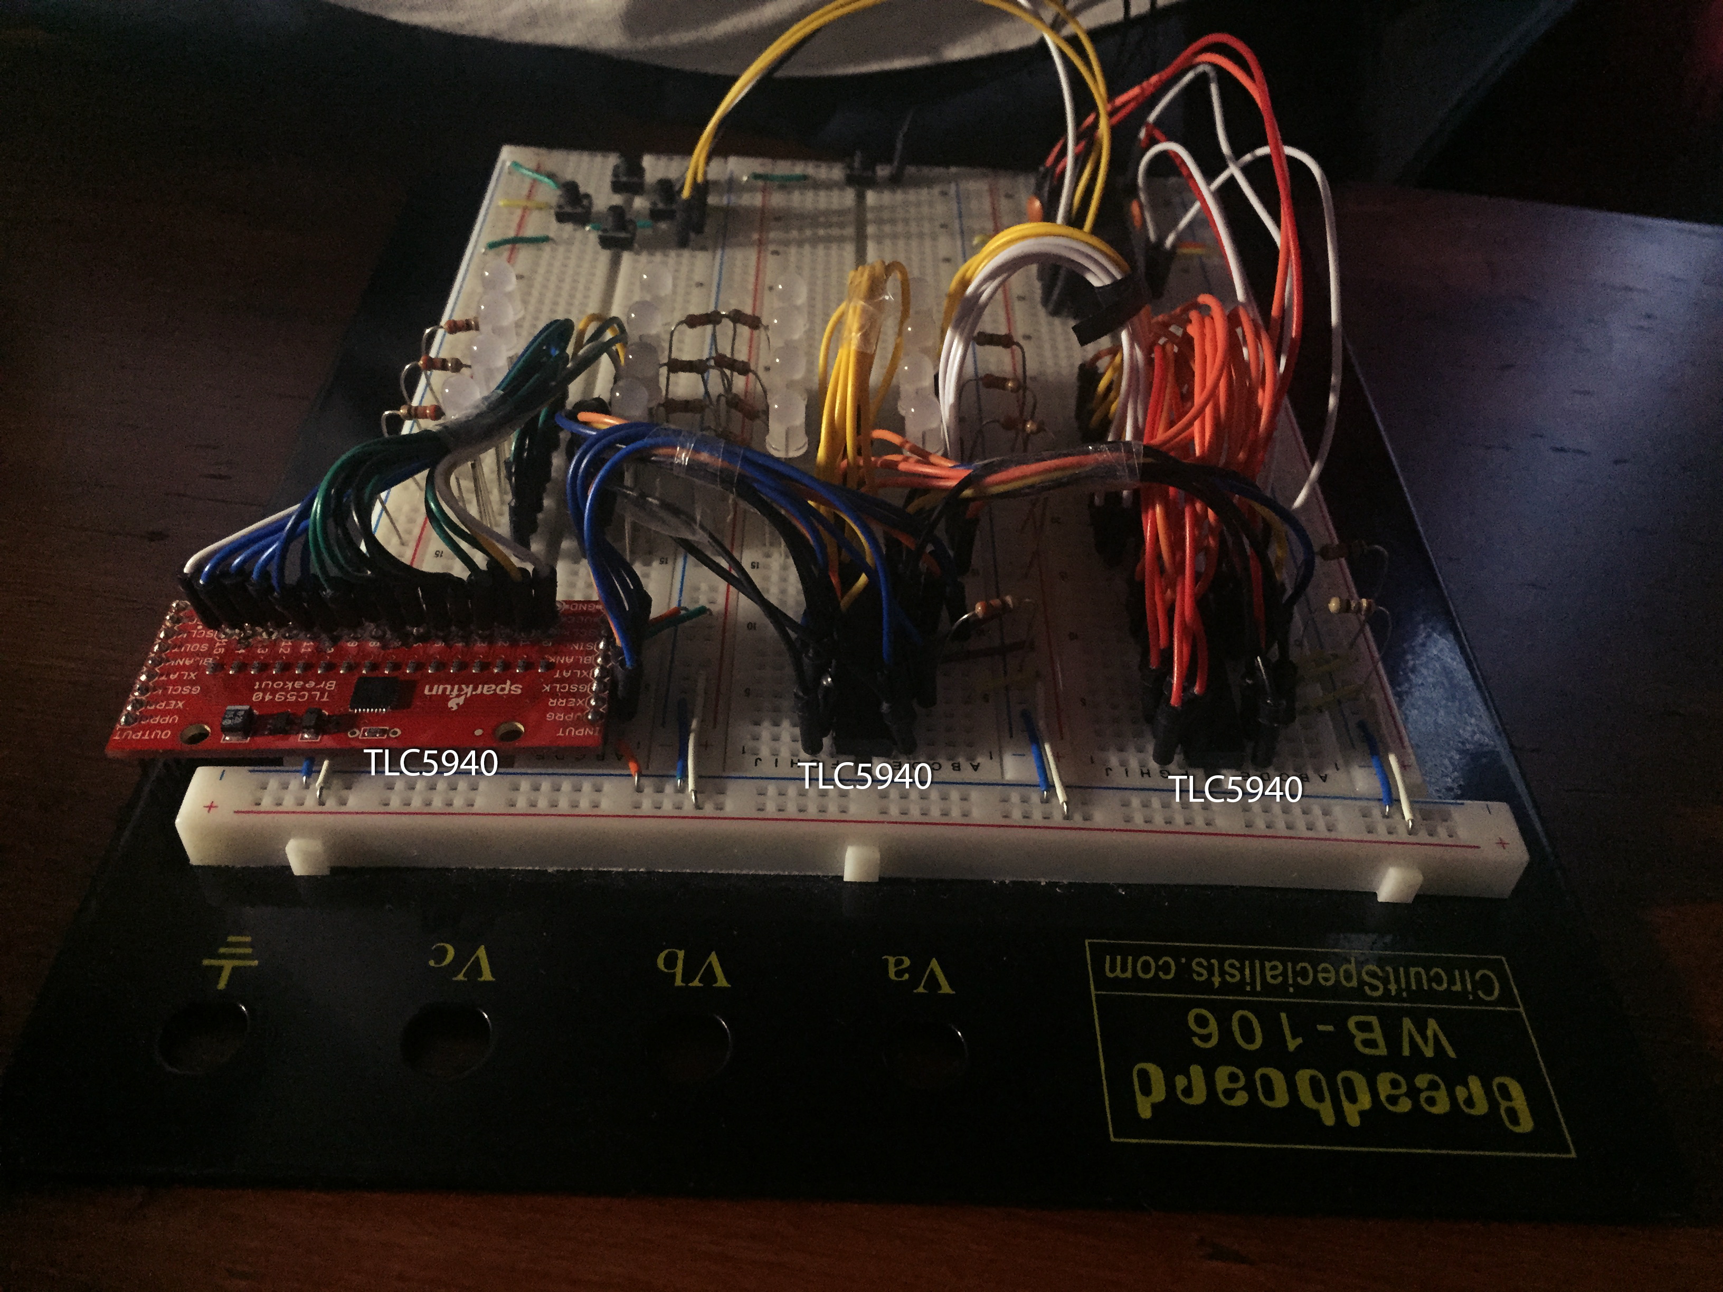

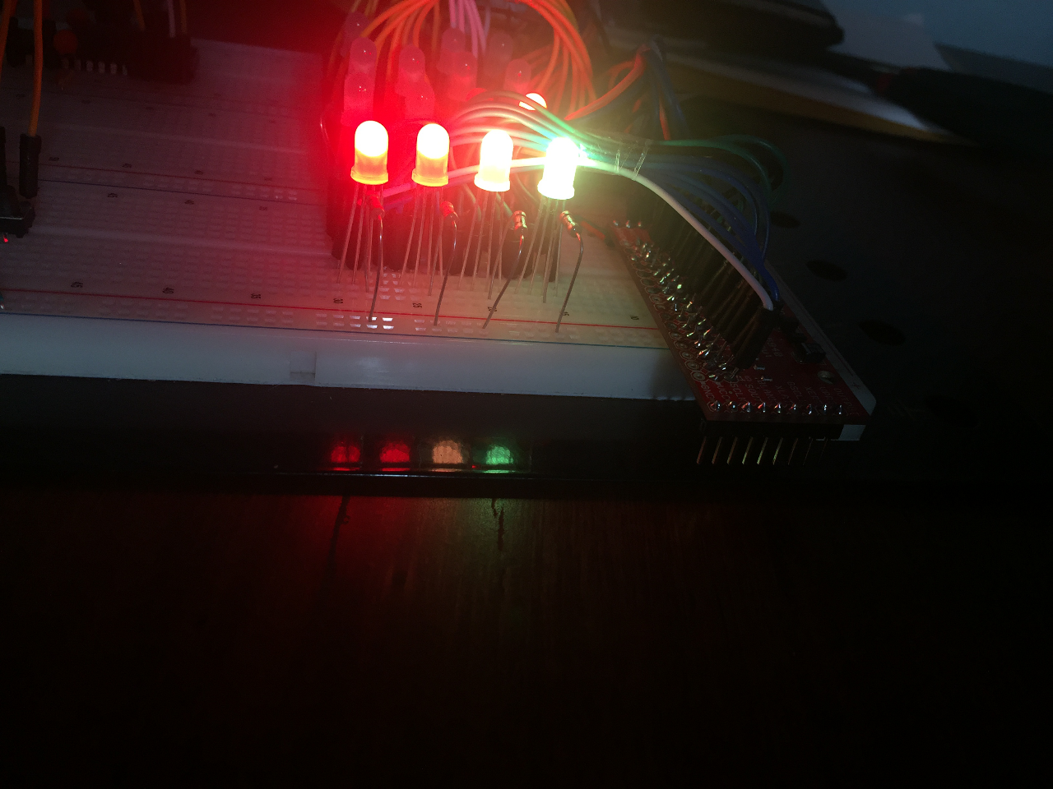

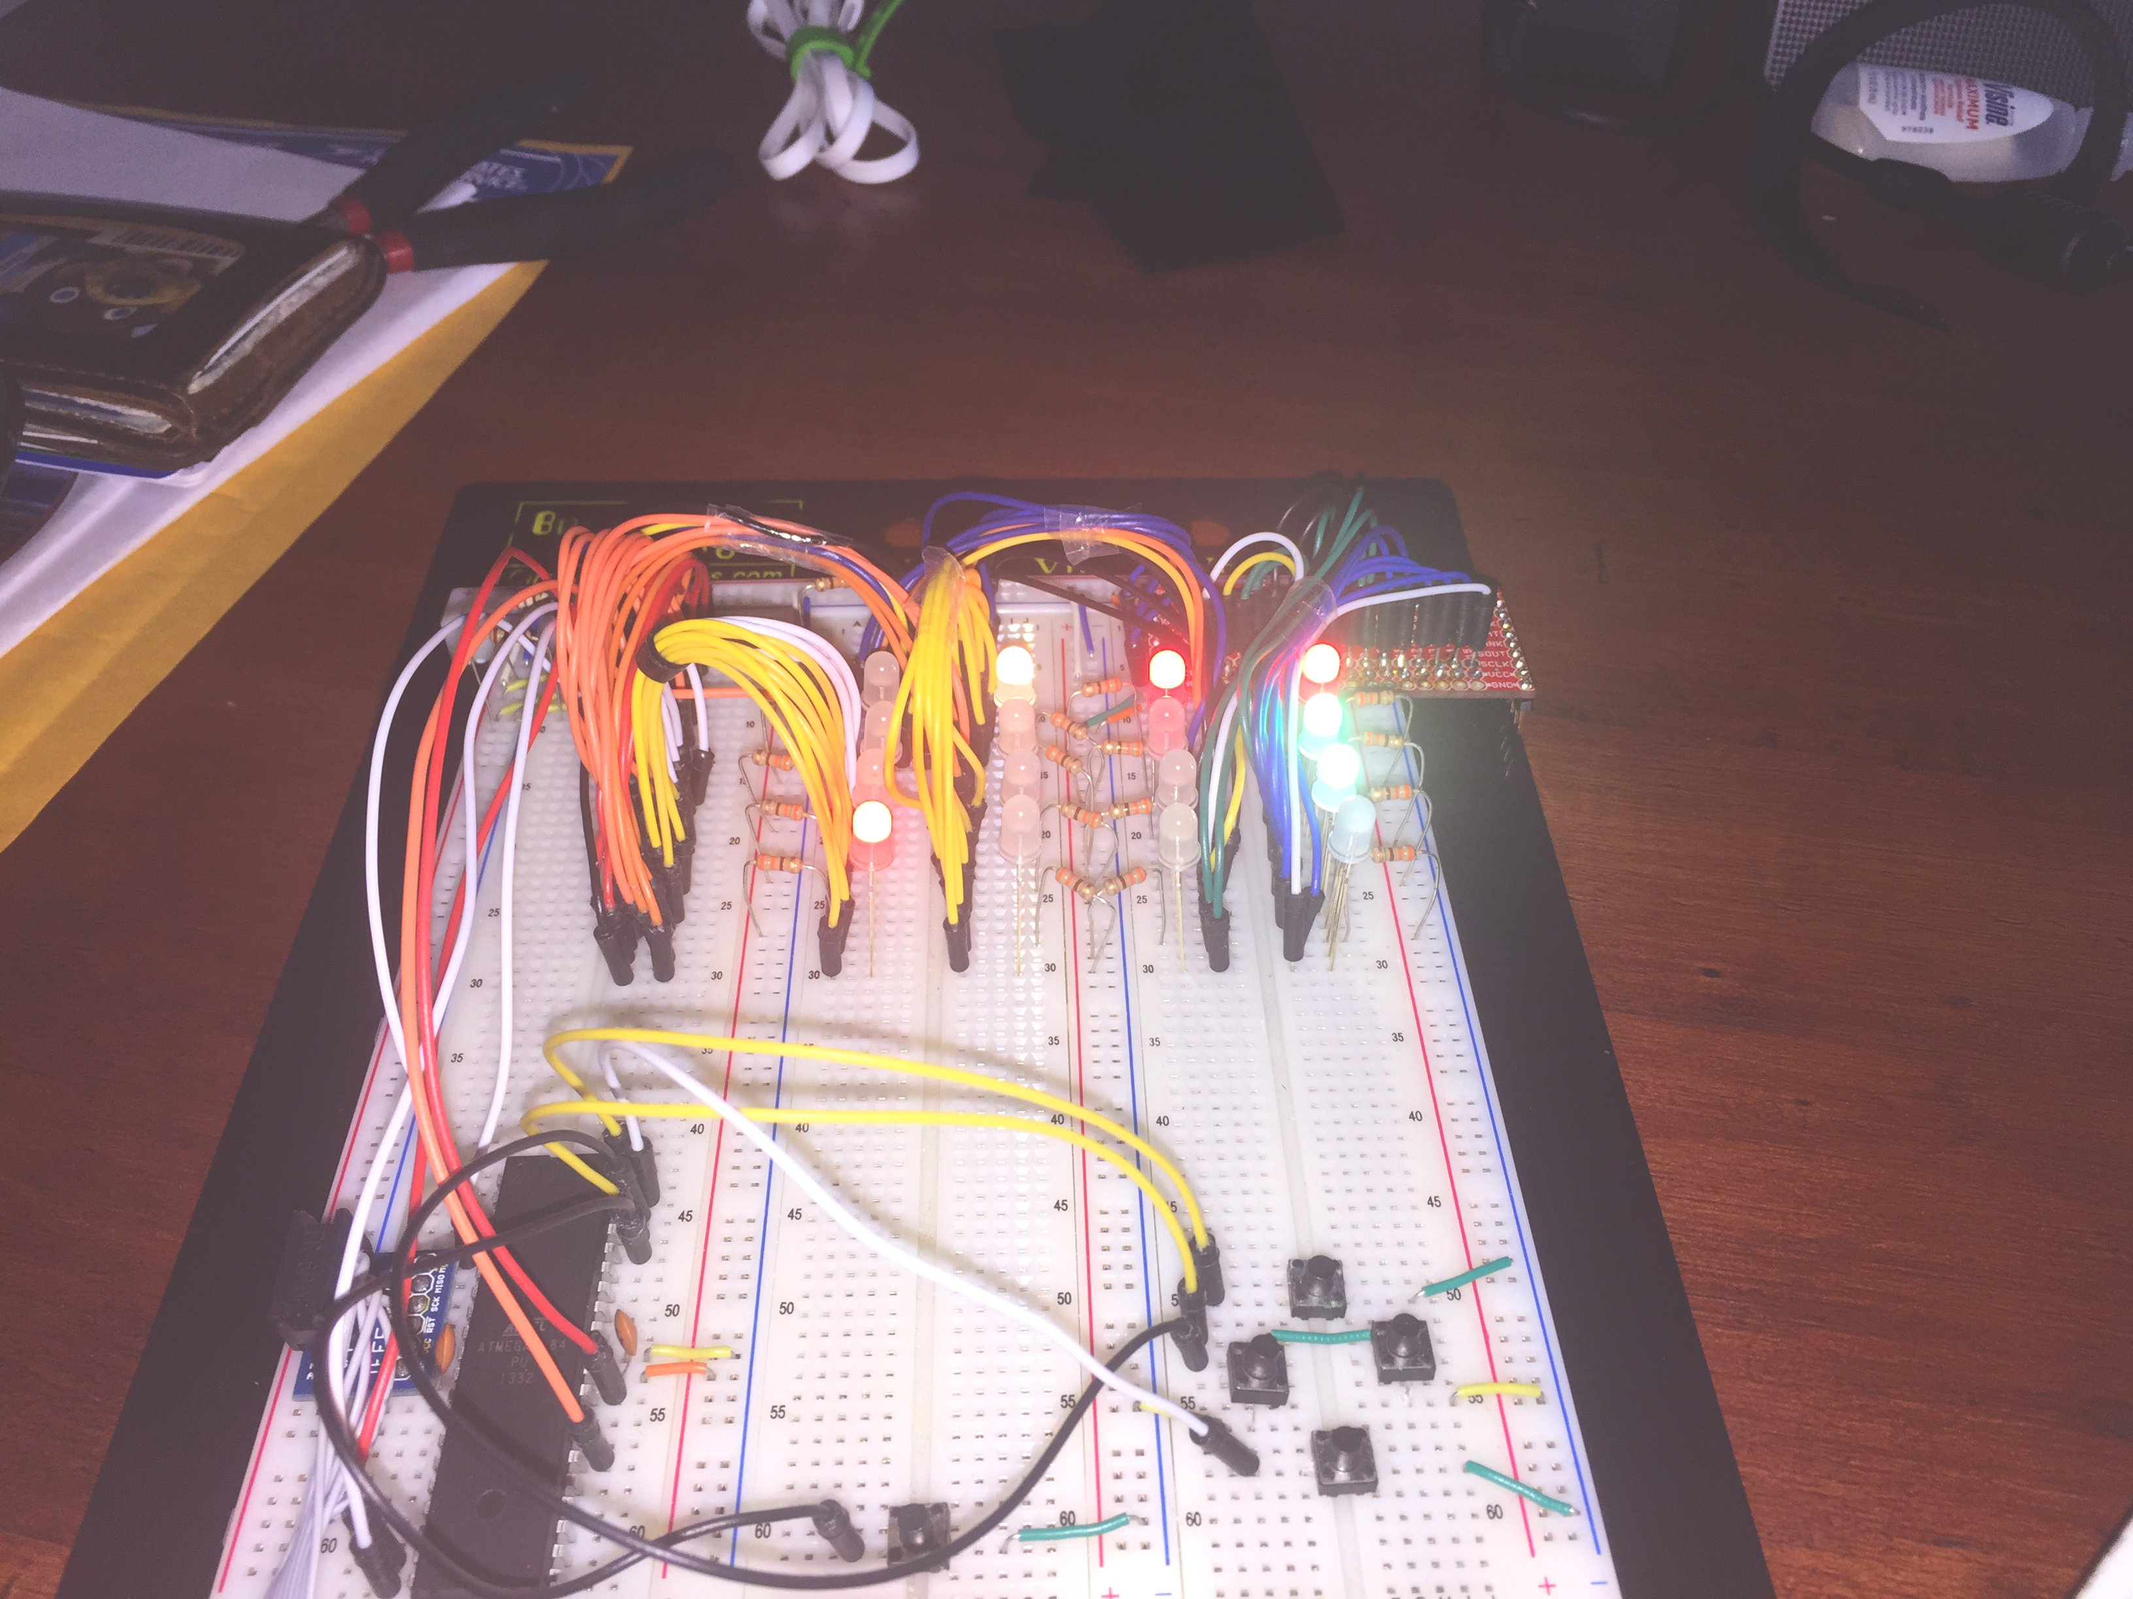

**Walkthrough of Code**

Initializing ports on the atmega1284 to be able to use with the TLC5940

If not using the atmega1284, use this datasheet of TLC5940: <http://www.ti.com/lit/ds/symlink/tlc5940.pdf> to match pins for your avr

//OCR1A = PD5

#ifndef TLC5940_GS_PORT

#define TLC5940_GS_PORT PORTD

#endif

#ifndef TLC5940_GS_PIN

#define TLC5940_GS_PIN 5

#endif

// serial clock -OC0B PB4

#ifndef TLC5940_SCK_PORT

#define TLC5940_SCK_PORT PORTB

#endif

#ifndef TLC5940_SCK_PIN

#define TLC5940_SCK_PIN 4

#endif

// latch - PC4

#ifndef TLC5940_XLAT_PORT

#define TLC5940_XLAT_PORT PORTC

#endif

#ifndef TLC5940_XLAT_PIN

#define TLC5940_XLAT_PIN 4

#endif

// programming select - PC7

#ifndef TLC5940_VPRG_PORT

#define TLC5940_VPRG_PORT PORTC

#endif

#ifndef TLC5940_VPRG_PIN

#define TLC5940_VPRG_PIN 7

#endif

// blank outputs - OC2B pullup resistor + PD6

#ifndef TLC5940_BLANK_PORT

#define TLC5940_BLANK_PORT PORTD

#endif

#ifndef TLC5940_BLANK_PIN

#define TLC5940_BLANK_PIN 6

#endif

// serial data master out slave in OC0A- PB3

#ifndef TLC5940_MOSI_PORT

#define TLC5940_MOSI_PORT PORTB

#endif

#ifndef TLC5940_MOSI_PIN

#define TLC5940_MOSI_PIN 3

#endif

#ifndef TLC5940_N

#define TLC5940_N 3

#endif

#define TLC5940_LED_N 16 * TLC5940_N

**Initialize empty grid and blank led matrix**

int grid[4][4];

int wonGame = 0;

//initialize the grid to all 0

void initializeGrid() {

for (int i = 0; i < 4; i++) {

for (int j = 0; j < 4; j++) {

grid[i][j] = 0;

}

}

}

**Generate 2 random ‘2’ tiles for the start of the game. First call matrix_to_rgb to set the the 2 ‘2’ tiles to red on the grid**

initializeGrid();

generateRandom();

generateRandom();

matrix_to_rgb(2);

**matrix_to_rgb() takes an int (0 for loss, 1 for win, anything else is play on)**

Now the led matrix should have 2 random leds illuminated as red

Set up user input via buttons

while(1) {

_delay_ms(50);

buttonUp = ~PINA & 0x01;

buttonDown = ~PINA & 0x02;

buttonLeft = ~PINA & 0x04;

buttonRight = ~PINA & 0x08;

buttonReset = ~PINA & 0x10;

}

**When button press is detected and it is not reset**

if (buttonUp && !buttonDown && !buttonRight && !buttonLeft && !buttonReset) {

pressUp();

**check if it is a valid move, if it is, generate random and update the grid**

for (int i = 0; i < 4; i++) {

for (int j = 0; j < 4; j++) {

if (grid[i][j] != grid_prev[i][j]) {

validmove = 1;

}

}

}

if (validmove == 1) {

generateRandom();

validmove = 0;

}

matrix_to_rgb(2);

**Before running another turn, check if the game is won**

checkWin();

if (wonGame == 1) {

wonGame = 0;

while (!buttonReset) {

matrix_to_rgb(1);

_delay_ms(3000);

buttonReset = ~PINA & 0x10;

}

}

_delay_ms(50);